Text Area Display field title set to NO but text does not spread across the full width;



Tried lots of variations of columns and size etc but no change
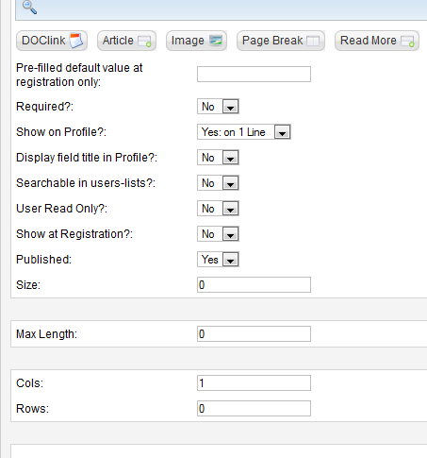

Tried to edit the css to 100% but text drops to 2 lines for all fields which is not what I want;
form.cb_form .cb_form_line .cb_field , .cb_tab_content .cb_form_line .cb_field
{ display: block; float: left; width: 70%; font-weight:normal; vertical-align: top; }
