We use CB only for making it possible for users to maintain some information. So they have nothing to do with a front-end language and a timezone so I want to get rid of it.
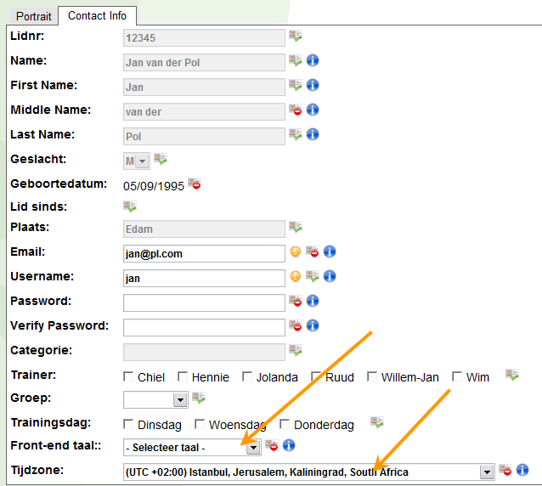

I tried to disable the field params but it seems that this is not possible. There I noticed that the field is on the ‘Contact info’ tab and moving it to the ‘Portrait’ tab is a step in the right direction.
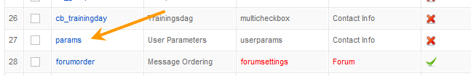

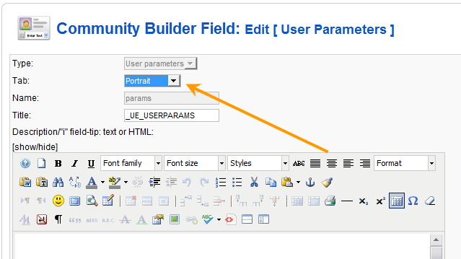
In the front-end it now looks like this:
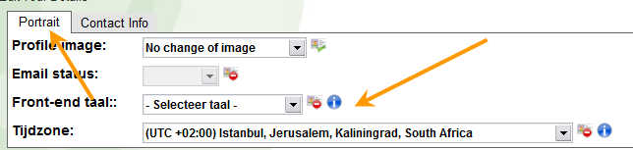
Because we don’t use a profile image, disabling the ‘Portrait’ tab is a good idea and I can do that by unpublish that tab:
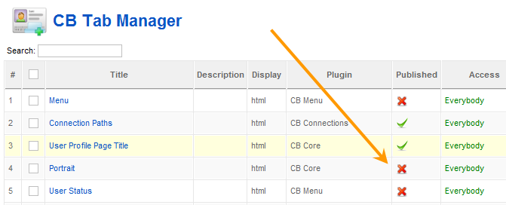

At this point the problem shows up. When I want to edit a user in the backend the javascript error ‘Not authorized’ appears and it isn’t possible to save any change.
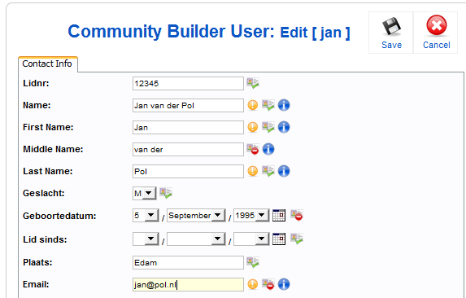

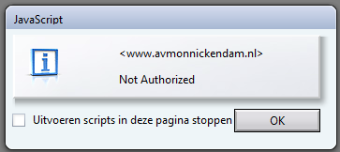
This is not a workable situation but I had no idea that the problem was caused by disabling the ‘Portrait’ tab.
Fortunately spfaehler came with the solution. I enabled the ‘Portrait’ tab again by making it published and gave only administrators access to that tab.
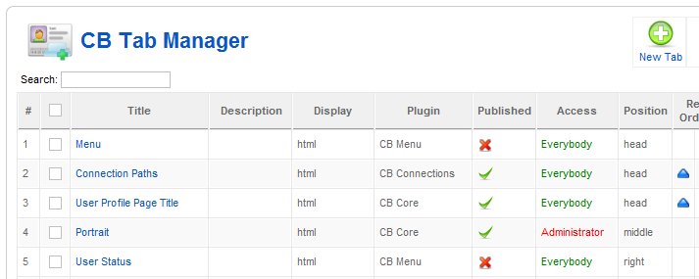
Now the front-end looks exactly as I want for registered users:
