Create a New Relief Request
Store the request with an Internal ID. People can save the request and come back to it again later.
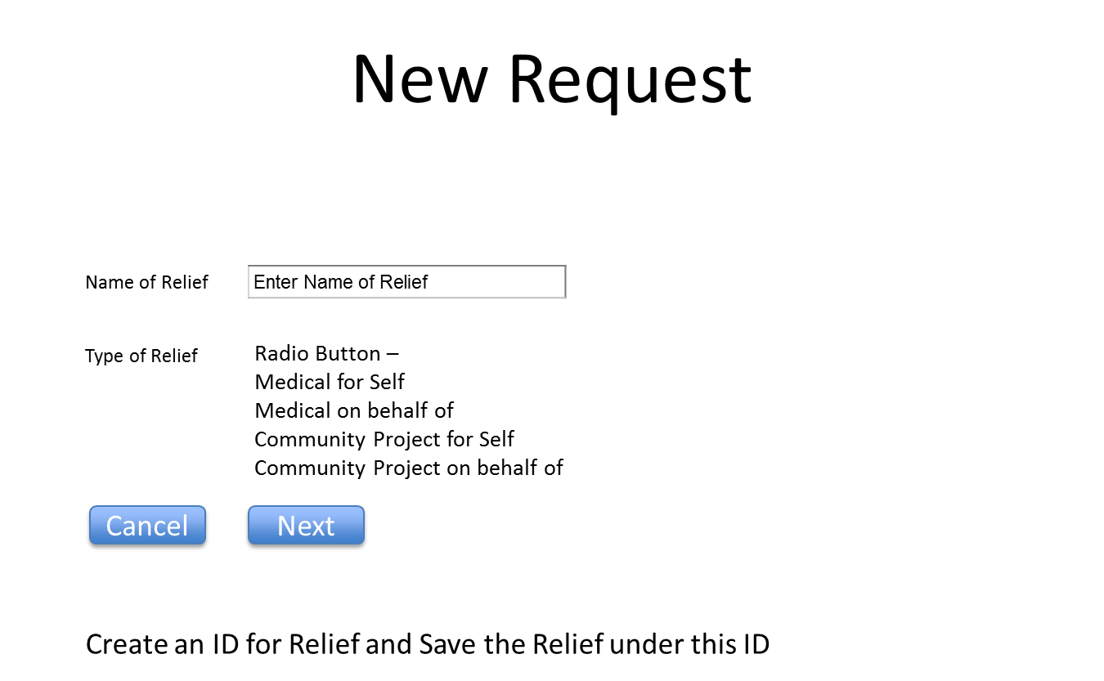

You can change the progress portion of the below screen shots if you have other better ways of implementing. What I have showed is for illustration purposes ONLY.
